ASSIGNMENT DAY 10: Hypothesis

Name: Arati

This analysis and hypothesis formation is done on the data provided by in the general_data.csv file.

1. Hypothesis: Less people are receiving salary > 150000. Employees having Monthly Income less than average have high attrition rate.

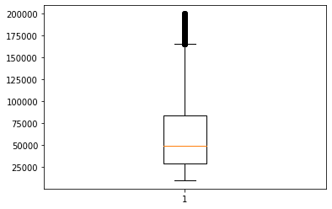

1. Hypothesis: People are leaving the companies after working for around 17 years and a very few people stay with the company after 17 years. Years at company is also Right Skewed with several outliers observed.

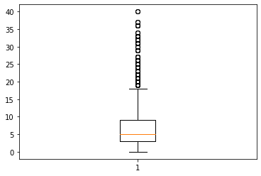

1. Hypothesis: Average age of employee is 42 years. Here we say that that people over all the age groups can be admitted in the company as this one factor is not causing any attrition.

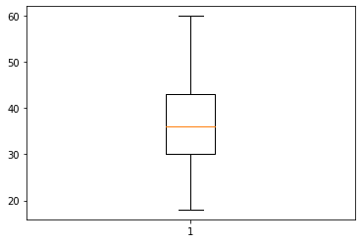

1. Hypothesis: Highly educated employees have high attrition rate. The maximum of the employees are highly educated.

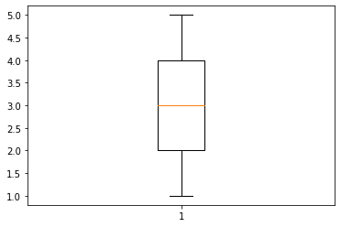

1. Hypothesis: Employees having worked less than 5 years with the Current Manager have high attrition rate.

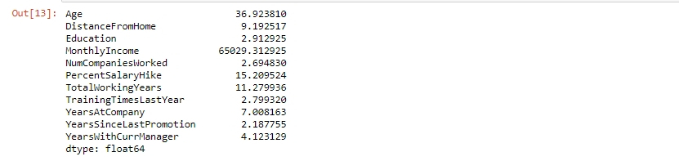

1. Hypothesis: Most of the employees love to travel.

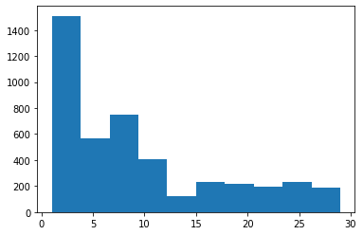

1. Hypothesis: Percent of Salary Hike is equally distributed among the employees.

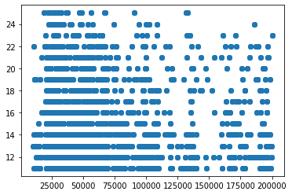

1. Hypothesis: The mean percentage in salary hike of the attrited employees is not less than 15.

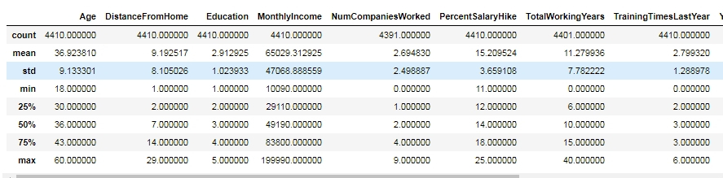

1. Hypothesis: Mean of total working years of attrited employees is greater than 10 years



1. Hypothesis: Mean of training times last year is not equal to 2.

